HOMEWORK 1:

Using cvxpy to solve (<https://www.cvxpy.org/tutorial/intro/index.html>)

1. Diet problem

To live a healthy life, I needs:

* + ≥ 200 grams of carbohydrates.
  + ≥ 20 grams of proteins.
  + Other nutrients (ignored for now).

Food sources at grocery store:

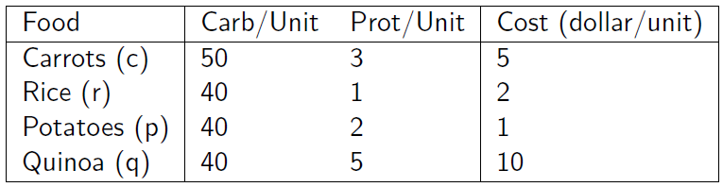

Question: How can I satisfy my nutritional needs while paying the least amount of money possible?

1. House’s price estimation problem.